Muhammad Muneeb

Agile Methodology

**Agile scrum methodology**

Agile scrum methodology is a project management system that relies on incremental development. Each iteration consists of two- to four-week sprints, where the goal of each sprint is to build the most important features first and come out with a potentially deliverable product.

5 Scrum stages that are of effective management

* Initiation.
* Planning and estimation
* Implementation
* Reviewing
* Releasing

For this scenario we use scrum agile methodology. So we implement application in increments

**Scrum backlog**

First we make sprint backlog which is made by scrum team and product owner help them to n specify the requirement according to their priority

In this scenario product backlog is

* Application that is used to design or decorate houses, room, shops, and offices.
* Application run on both iOS and Android.
* Application works on 2 ways shopkeeper upload pictures and User can view images.
* By using camera User can see how the objects looks at his wall.
* Application measure the size of wall and xyz coordinates of objects.
* Convert 2D image into 3D.
* The application will be able to set multiple objects and create interior decorate according to room size
* After making backlog we make sprints backlog
* Daily scrums
* Increments

In every increment we get a milestone.

**Increment 1**

In increment 1 we implements first most important feature in the product backlock. This activity can take 1 month

|  |  |  |
| --- | --- | --- |
| Start Date | End Date | Features which in implemented |
| 1 March | 30 March | * Application that is used to design or decorate houses, room, shops, and offices. * Application run on both iOS and Android. * Application works on 2 ways shopkeeper upload pictures and User can view images. |

**Increment 2**

|  |  |  |
| --- | --- | --- |
| Start Date | End Date | Features which in implemented |
| 20 March 2022 | 10 April 2022 | * By using camera User can see how the objects looks at his wall. * Application measure the size of wall and xyz coordinates of objects. |

**Increment 3**

|  |  |  |
| --- | --- | --- |
| Start Date | End Date | Features which in implemented |
| 10 April 2022 | 5 May 2022 | * Convert 2D image into 3D. * The application will be able to set multiple objects and create interior decorate according to room size |

**Gantt Chart**

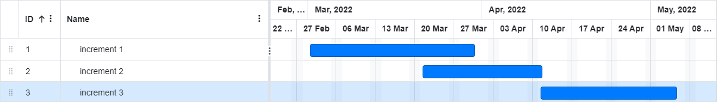

**Type of testing to be applied**

Android and iOS base testing is applied in the app to check whether the is working in both machines

**Unit tests**

We do unit testing on every phase to check that the module according to the requirements.

**Integration testing**

We do integration testing to check whether the increments is compactable with other increments.

**Functional testing**

We functional testing is to check whether the software working properly

And it has all the function which is specified in requirement documents

**Acceptance testing**

In the scrum approach we do acceptance testing on every sprint to conformance from the owner side

**Who is responsible of testing?**

Tester is responsible for testing and developers change if anything gets wrong